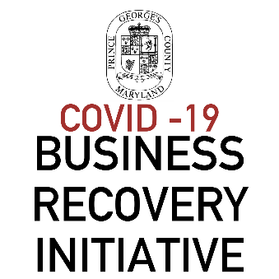

Justification for Additional Need
Prince George’s County has set aside $20 million to fund the County’s new COVID-19 Business Recovery Initiative (BRI). The BRI will replace the multi-million-dollar Prince George’s County COVID-19 Business Relief Fund, which provided low-cost loans of up to $100,000 and grants up to $10,000. The primary difference between the two funds is that, all disbursements from the BRI will be grants up to $100,000.
If your businesses received a grant through the COVID-19 Business Relief Fund (BRF), and would like to request additional funding support, please complete and submit the following form and supporting documentation to pgccovidrelief@co.pg.md.us. Additional grant funding is subject to availability and requests for additional funding will only be considered after all initial funding requests for the BRI program have been awarded.
*Additional funding request from businesses that received a loan that has been converted into a grant will not be considered.
Application ID#
Borrower Name:
Business Address:
Industry Sector:
COVID-19 Business Relief Fund (BRF) Grant Amount Received: | $
Use of BRF Funds:

NEW COVID-19 Business Recovery Initiative (BRI) Grant Request: | $
Use of BRI Funds:

Justification for Request - Describe need for additional funding support. (Not to exceed 500 words)

How is does your businesses plan to resume operations? (Not to exceed 500 words)

